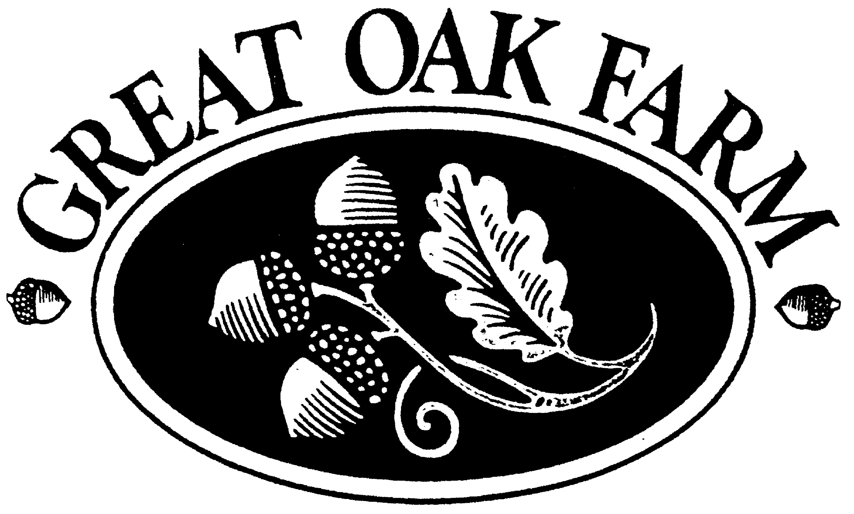

GREAT OAK FARM HOMEOWNER’S ASSOCIATION INC.
April 14th, 2022
Executive Session Meeting 7:00pm
Regular Board Meeting 7:30pm
(Need TEAMS meeting login info)

Call to Order

Roll Call of Board Members

Executive Session to discuss pending ARB violations

Review of Minutes

Finance Committee: Eddy Rodriguez
- Status Report
- Questions/issues

Landscape Committee: Anthony DePalma
- Old Business
  - Pergola install
    - Footings/pavers update
  - Pond clean-up
  - New Business
    - Gate house rehab estimates
    - Fence and pump-house power washing
- Questions/issues

ARB Committee: Brian Lindwall-Thomas
  - Old Business
- Solar panels
- Fence repair on Secret Hollow
- GOF Spring clean-up day - date changed to 4/24/22 (Passover is 4/23)
  - New Business
    - Spring walk-through set for 4/30 (rain date 5/1)
    - Branch removal mishap
  - Questions/issues

Septic Committee: Russ Simpkins
- DEEP Septic Permit update
- Questions/issues

Streets Committee: David Orr
- Old business
  - Speed bumps
  - Stop sign resetting estimate from CEO Landscaping (Anthony)
  - Catch basin at top of Cannon Way was a frost heave (per Tri-State)
- New business
  - Crack sealing
  - Curb repair
  - Street sweeping
  - Catch basin clean-out
  - Questions/issues

Website: Eddy Rodriguez
  - Update
  - Questions/issues

Social: David Orr & Adrienne Stepkoski
  - Easter Egg Hunt set for Saturday 4/9/22
  - Summer events
  - Newsletter

Bookkeeping (Janice Elliott)

Open comment for residents

Adjournment

